UNIVERSITY OF RWANDA
COLLEGE OF SCIENCE AND TECHNOLOGY
DEPARTMENT OF COMPUTER AND SOFTWARE ENGINEERING

WEB DESIGN TECHNICAL REPORT
AGRISMART: SMART AGRICULTURE MANAGEMENT SYSTEM

Submitted by:
Name: ISHIMWE NIYOYITA Kevin
Registration Number: 225074650
Year of study: Year 1
Institution: University of Rwanda
College: College of Science and Technology
Department: Computer and Software Engineering
Module: Web Design
Academic Year: 2025-2026

TABLE OF CONTENTS
TABLE OF CONTENTS 2
TABLE OF FIGURES 4
LIST OF ABBREVIATIONS 5
CHAPTER ONE: INTRODUCTION 6
1.1 Background 6
1.2 Problem Statement 6
1.3 General Objective 6
1.4 Specific Objectives 6
1.5 Expected Outcomes 7
1.6 Project Rationale 7
CHAPTER TWO: SYSTEM ANALYSIS AND DESIGN 8
2.1 Existing vs. Proposed System 8
2.2 System Design 8
2.2.1 High-Level Architecture 8
2.2.2 UI Design (Site Map / Navigation Flow) 8
2.2.3 Database Design (ERD and Relationships) 9
2.3 Requirements 10
2.3.1 Functional Requirements 10
2.3.2 Non-Functional Requirements 10
2.4 User Interface Pages 10
CHAPTER THREE: IMPLEMENTATION 12
3.1 HTML, CSS & JavaScript 12
3.2 Folder Structure 12
3.3 Forms, Navigation & Responsiveness 12
3.4 Coding Standards & Challenges 12
3.5 Screenshots of Implemented Pages 12
3.5.1 Home Page 12
3.5.2 Contact Page 13
3.5.3 Login Page 14
3.5.4 Registration Page 15
3.5.5 User (Farmer) Dashboard 16
3.5.6 Administrator Dashboard 17
CHAPTER FOUR: TESTING 18
4.1 Test Cases and Results 18
4.2 Summary 19
CHAPTER FIVE: CONCLUSION AND RECOMMENDATIONS 19
5.1 Conclusion 19
5.2 Strengths and Limitations 19
5.3 Recommendations 19
What do you recommend? 19
To the lecturer, about technicalities 20
To the school, about time constraints 20
To the partners (owners of the business/sector targeted), about the app developed 20
To the user, about training 20
To the beneficiaries (farmers, buyers, and cooperative members), about the new technological tool 20
REFERENCES 20
APPENDICES 21
Appendix A: Selected Source Code 21
Appendix B: GitHub Repository Access 21

TABLE OF FIGURES
Figure : High-Level Architecture 8
Figure : UI Design (Sketch of the UI Module) 9
Figure : Entity Relationship Diagram (ERD) of the AgriSmart Database 10
Figure : Home Page 13
Figure : Contact Page 14
Figure : Login Page 15
Figure : Registration Page 16
Figure : User Dashboard 17
Figure : Administrator Dashboard 18
Figure : Selected Source Code Excerpts 21

LIST OF ABBREVIATIONS
The table below defines every abbreviation and acronym used throughout this report.
Abbreviation | Full Meaning
ICT | Information and Communication Technology
ICT4Ag | Information and Communication Technology for Agriculture
HTML | HyperText Markup Language
CSS | Cascading Style Sheets
JS | JavaScript
UI | User Interface
UX | User Experience
ERD | Entity Relationship Diagram
DBMS | Database Management System
API | Application Programming Interface
URL | Uniform Resource Locator
HTTP | HyperText Transfer Protocol
HTTPS | HyperText Transfer Protocol Secure
SQL | Structured Query Language
RAB | Rwanda Agriculture and Animal Resources Development Board
MINAGRI | Ministry of Agriculture and Animal Resources
PSTA | Strategic Plan for Agriculture Transformation
NGO | Non-Governmental Organization
GPS | Global Positioning System
Admin | Administrator

CHAPTER ONE: INTRODUCTION

1.1 Background
Agriculture is a backbone of Rwanda's economy, and the Government continues to promote ICT-driven transformation of the sector through initiatives such as the Strategic Plan for Agriculture Transformation (PSTA) and the National ICT Strategy. Despite this progress, many smallholder farmers still lack easy access to weather, market, and buyer information. AgriSmart is a web-based Smart Agriculture Management System, developed for the Web Design module, that consolidates these services into one responsive platform for farmers, buyers, cooperatives, and administrators.

1.2 Problem Statement
Farmers currently face several interrelated challenges that limit productivity and income:
- Poor access to accurate, localized weather information.
- Limited direct access to buyers, increasing dependence on middlemen.
- Lack of reliable, up-to-date market price information.
- Limited access to modern farming knowledge and best practices.
- Weak communication channels between farmers, buyers, and institutions.

1.3 General Objective
To design and develop a responsive, web-based Smart Agriculture Management System (AgriSmart) that gives farmers, buyers, cooperatives, and administrators centralized access to weather, market, and communication tools, improving agricultural productivity and market efficiency in Rwanda.

1.4 Specific Objectives
- Design a responsive, intuitive interface using HTML5, CSS3, and JavaScript.
- Develop secure registration and login workflows for all user roles.
- Provide a weather forecast page with localized information.
- Provide a market prices page for major commodities.
- Provide a farming tips section with agricultural best practices.
- Enable buyers to post requests visible to farmers.
- Build farmer and administrator dashboards with role-relevant data.
- Test the system's functionality, usability, and responsiveness.

1.5 Expected Outcomes
The project is expected to improve farmers' access to timely weather, market, and buyer information, reduce dependence on middlemen, and demonstrate applied web design competency through a working, responsive prototype that can later be extended with a full back end and live data integration.

1.6 Project Rationale
This project was chosen because agriculture remains central to Rwanda's economy and food security, yet the information gaps described in Section 1.2 continue to limit farmer productivity and income despite the country's broader digital transformation efforts. AgriSmart directly applies the skills taught in the Web Design module, HTML5, CSS3, JavaScript, responsive layout, and form validation, to a real, socially relevant problem rather than a purely theoretical exercise, giving the project both academic and practical value.
The rationale for undertaking AgriSmart can be summarized across its key stakeholders:
- Farmers: gain a single platform for weather, market prices, farming tips, and direct buyer contact, reducing reliance on costly intermediaries.
- Buyers: gain a faster, more transparent way to source produce directly from registered farmers.
- Government and cooperatives: gain a working reference platform that supports national ICT4Ag and agricultural digitalization goals.
- Students and the university: gain a practical demonstration of how front-end web technologies can be applied to solve a real development challenge.
- Society: benefits from stronger food security, fairer pricing, and continued rural digital inclusion.

CHAPTER TWO: SYSTEM ANALYSIS AND DESIGN

2.1 Existing vs. Proposed System
Farmers currently rely on informal sources, such as radio and word-of-mouth, for weather and market information, and sell mostly through middlemen who control pricing. This causes information asymmetry and income loss. AgriSmart addresses this by centralizing weather, market prices, farming tips, and buyer-farmer interaction in one responsive web platform, reducing reliance on intermediaries and informal channels.

2.2 System Design

2.2.1 High-Level Architecture
AgriSmart is built around a Web Platform that hosts all core pages and features, from public content (Home, About, Services, Contact) through authentication, farmer and administrator dashboards, weather, market prices, farming tips, and buyer requests. This Web Platform communicates through an application logic/API layer to a central database, and the architecture is designed so that a future Mobile App and external data services (live Weather and Market Price APIs) can plug into the same API layer without redesigning the core system.
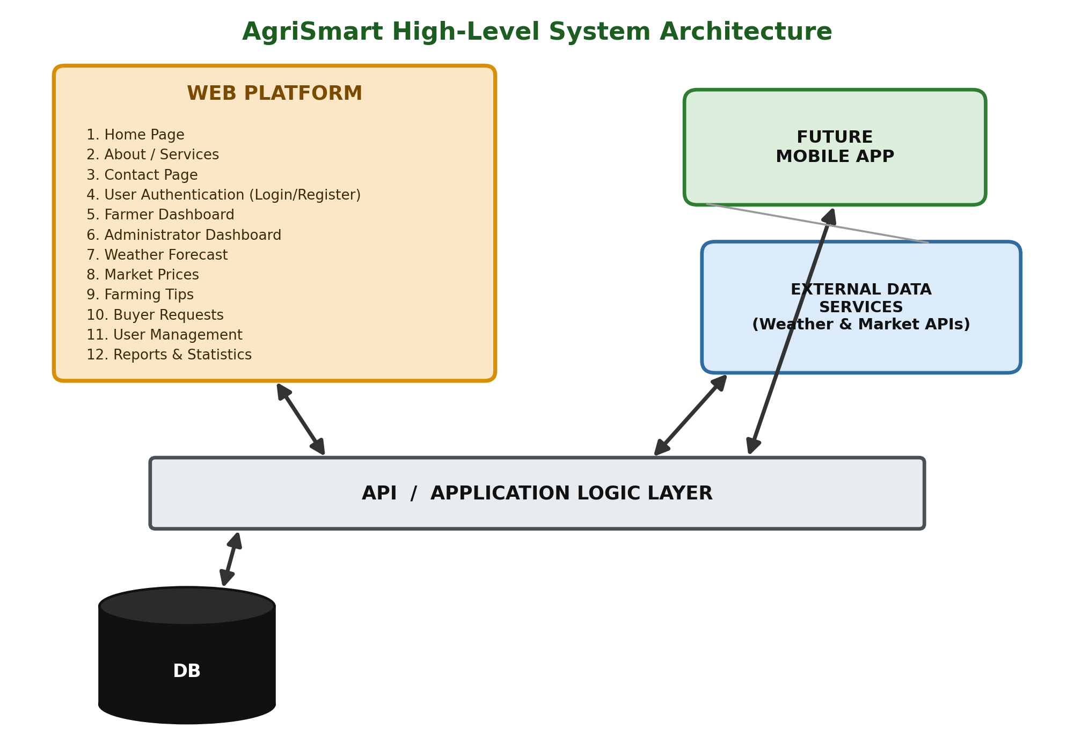
Figure 1: High-Level Architecture

2.2.2 UI Design (Site Map / Navigation Flow)
The site map below models the UI design of AgriSmart, showing how a visitor moves from the entry point through the public pages into Login, and how the administrator's modules (Dashboard, Manage Users, Manage Farmers, Manage Market Prices, Custom Reports, User Logs, and Settings) each expand into their own Create/List/Edit/Delete style sub-screens. This navigation flow guided the placement of menus, buttons, and page links throughout the implementation.
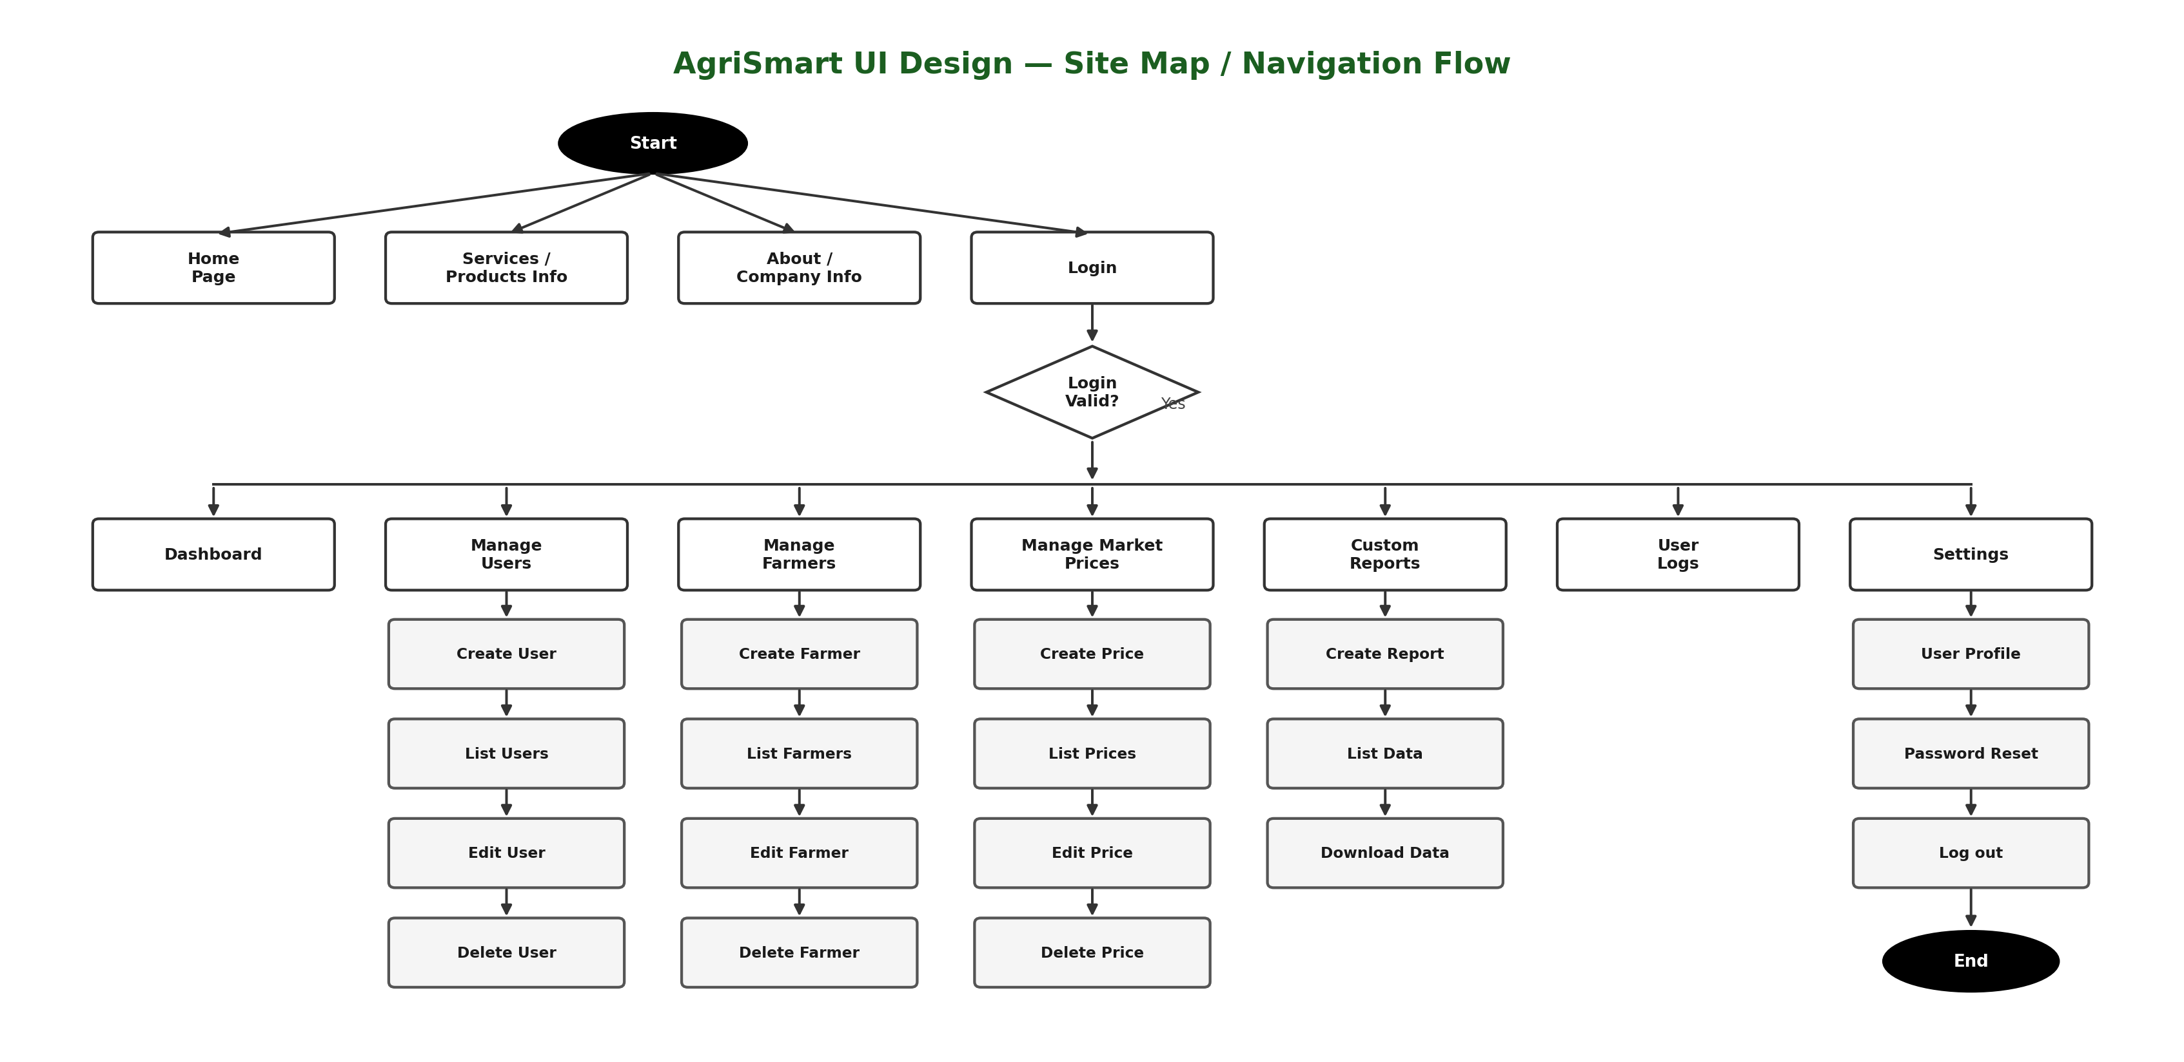
Figure 2: UI Design (Sketch of the UI Module)

2.2.3 Database Design (ERD and Relationships)
Although the current implementation of AgriSmart operates primarily as a front-end prototype, a conceptual database was designed to guide future back-end integration. The core entities are Users, Farmers, Buyers, Administrator, Crops, Weather Forecast, Market Prices, and Buyer Requests.
- Users: stores shared authentication attributes (user ID, username, email, hashed password, role) for every account type.
- Farmers: stores farmer-specific profile details (name, phone, district/sector, main crop, farm size) linked one-to-one with Users.
- Buyers: stores buyer-specific details (business name, contact information, preferred commodities) linked one-to-one with Users.
- Administrator: stores administrator-specific access details linked one-to-one with Users.
- Crops: a reference list of supported crop types, linked one-to-many with Farmers and many-to-one with Buyer Requests.
- Weather Forecast: stores forecast records (location, date, temperature, precipitation) read by Farmers and Buyers.
- Market Prices: stores commodity price records (commodity, unit, price, market, date) read by Farmers and Buyers.
- Buyer Requests: stores purchase requests (commodity, quantity, price range, status) linking Buyers to Crops in a many-to-one relationship.
These entities and their relationships are illustrated in the Entity Relationship Diagram (ERD) below.
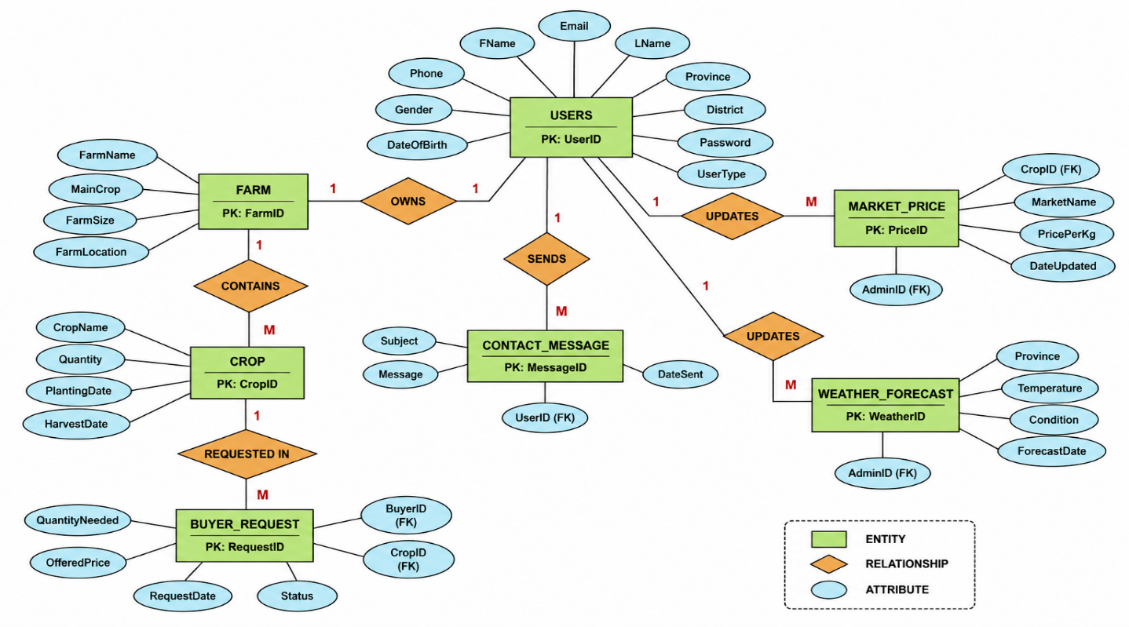
Figure 3: Entity Relationship Diagram (ERD) of the AgriSmart Database

2.3 Requirements

2.3.1 Functional Requirements
- Users can register and log in based on role (farmer, buyer, cooperative, administrator).
- The system validates all forms client-side before submission.
- Dedicated pages display weather forecasts, market prices, and farming tips.
- Buyers can post purchase requests visible to farmers.
- Farmer and administrator dashboards display role-relevant data and statistics.
- A contact form allows visitors to reach the AgriSmart team.

2.3.2 Non-Functional Requirements
- Performance: lightweight local assets for fast loading.
- Security: client-side validation, with secure authentication planned for the back end.
- Usability: consistent, simple navigation for varying digital literacy levels.
- Reliability & Maintainability: modular, well-organized codebase.
- Scalability: structure supports future roles, features, and database integration.

2.4 User Interface Pages
The table below summarizes the core pages implemented in AgriSmart; annotated screenshots of the live interface are presented in Chapter Three.
Page | Purpose
Home | Introduces AgriSmart and its key features.
About / Services | Describes the platform and services offered per user role.
Contact | Validated contact form for inquiries.
Login / Register | Authentication and role-based account creation.
Farmer Dashboard | Profile, buyer requests, weather and tips shortcuts.
Admin Dashboard | Platform-wide statistics and user management tools.

CHAPTER THREE: IMPLEMENTATION

3.1 HTML, CSS & JavaScript
Each page (home, about, services, contact, login, register, farmer dashboard, admin dashboard) was built with semantic HTML5, sharing a consistent header and footer. CSS3, using Flexbox/Grid and media queries, was organized in a central stylesheet for responsive, mobile-first layouts. Vanilla JavaScript handles form validation, mobile navigation toggling, and dynamic rendering of dashboard content, keeping all logic transparent and dependency-free.

3.2 Folder Structure
- HTML pages: index.html, about.html, services.html, contact.html, login.html, register.html, farmer-dashboard.html, admin-dashboard.html
- /css — stylesheets | /js — validation, navigation, dashboard scripts | /images — local image assets

3.3 Forms, Navigation & Responsiveness
All forms combine HTML5 validation attributes with JavaScript checks for required fields, email format, and password rules, giving users immediate feedback. A fixed navigation bar collapses into a mobile menu on small screens, and a mobile-first responsive approach with flexible grids and scalable typography keeps the layout usable on any device.

3.4 Coding Standards & Challenges
Consistent indentation, descriptive naming, and inline comments were used throughout for maintainability. The main implementation challenge was fine-tuning responsive breakpoints for the card layouts and dashboard tables, resolved through iterative testing and reference to MDN and W3Schools documentation.

3.5 Screenshots of Implemented Pages
This section presents annotated screenshots of the core AgriSmart pages as implemented, illustrating how the design decisions from Chapter Two were realized in the working system.

3.5.1 Home Page
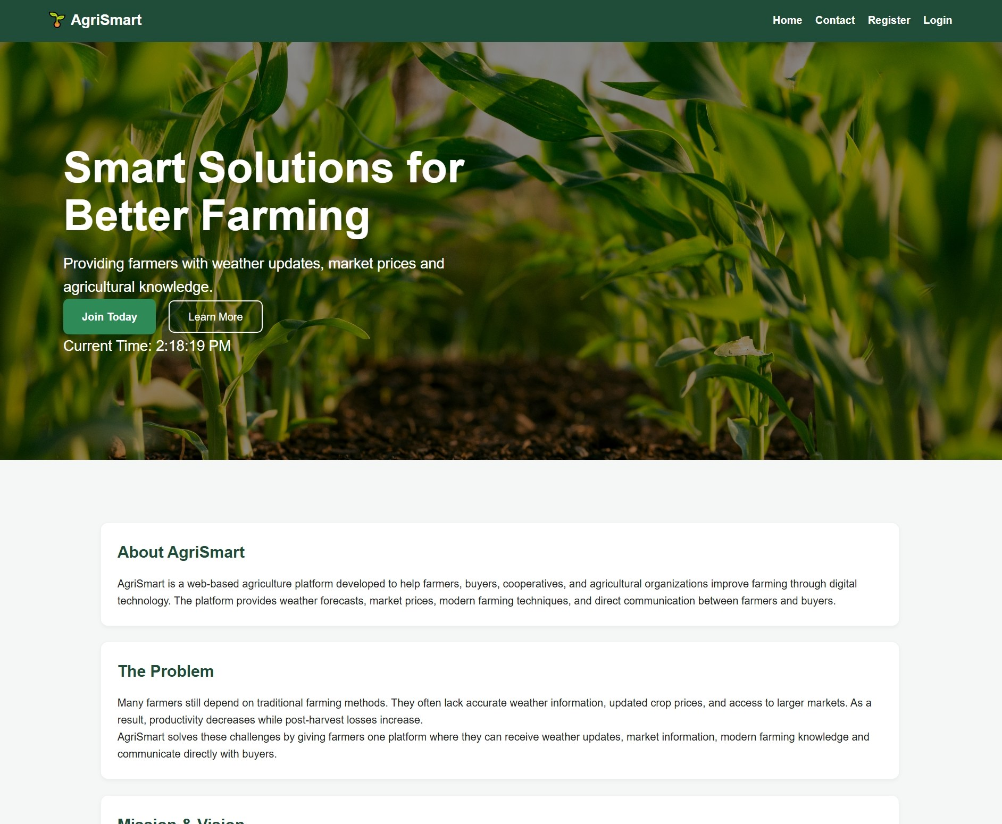
Figure 4: Home Page
The figure above shows the homepage of the AgriSmart Smart Agriculture Management System. The homepage provides users with an introduction to the system, a navigation bar linking to Home, Contact, Register, and Login, a hero section summarizing the platform's purpose, and dedicated blocks covering the About section, the problem being solved, the mission and vision, core services, platform statistics, and farmer testimonials.
This layout was intentionally designed to build trust and clearly communicate value to first-time visitors, farmers, buyers, and administrators alike, before directing them toward registration or login. The clean, card-based structure and consistent green color scheme reflect the platform's agricultural identity while keeping the page easy to scan on both desktop and mobile devices.

3.5.2 Contact Page
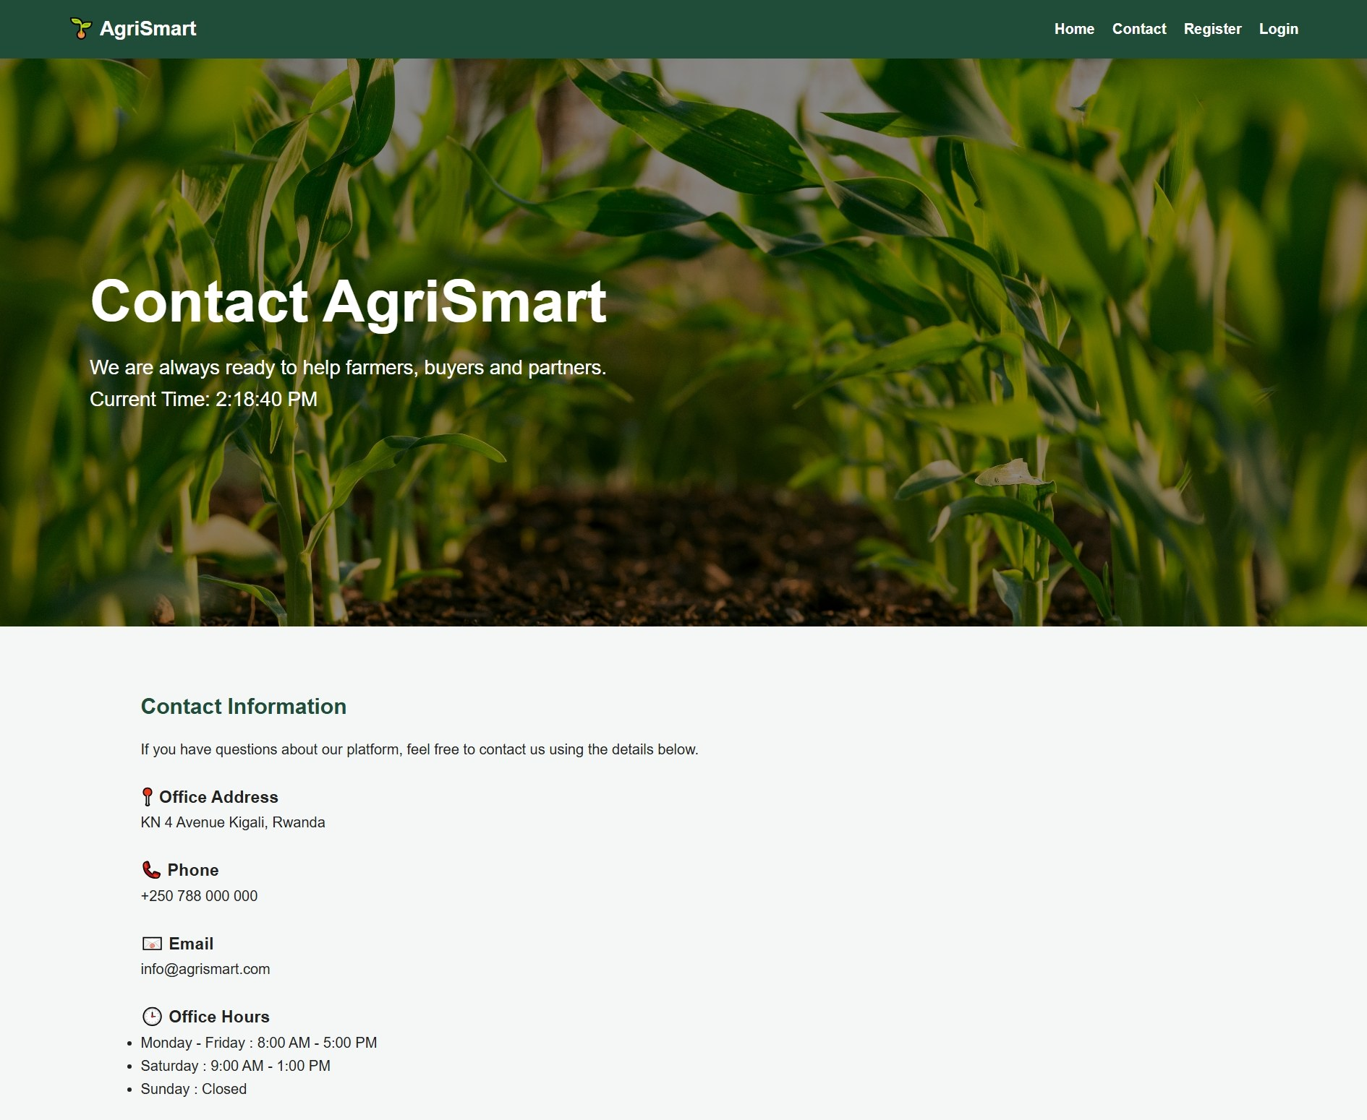
Figure 5: Contact Page
The figure above shows the Contact page, which displays the platform's office address, phone number, email address, and office hours alongside a validated contact form capturing the sender's full name, email, phone number, role (farmer, buyer, or other), subject, and message.
This page directly supports user communication by giving visitors multiple channels through which to reach the AgriSmart team, while the accompanying Frequently Asked Questions section addresses common queries before a message even needs to be sent, reducing unnecessary support requests.

3.5.3 Login Page
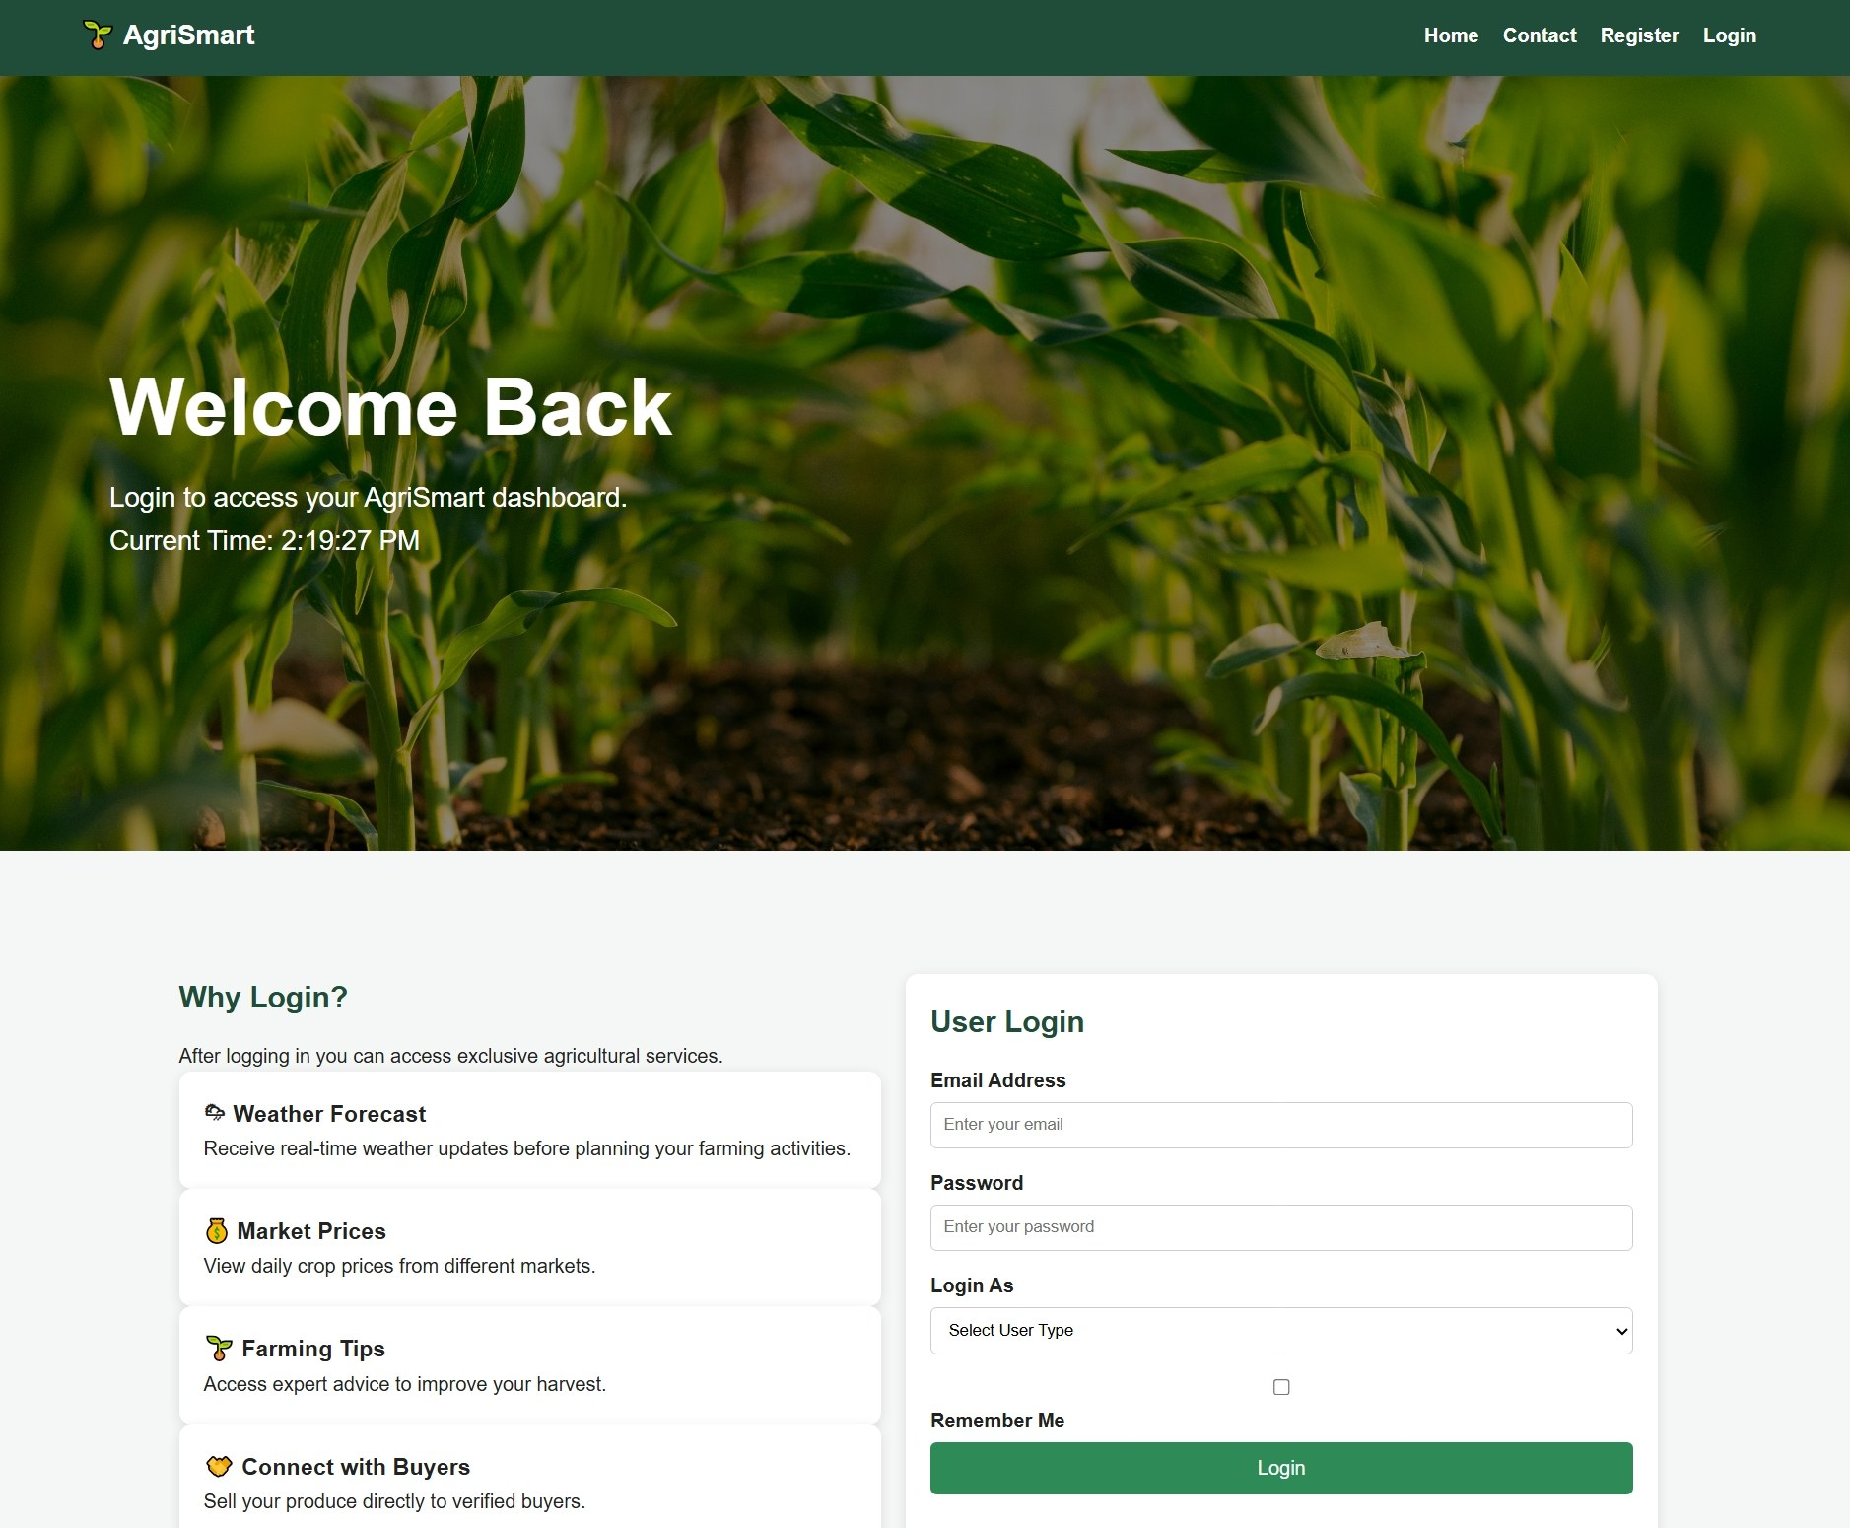
Figure 6: Login Page
The figure above shows the Login page, which authenticates existing users through an email address, password, and a "Login As" role selector that distinguishes between farmer, buyer, cooperative, and administrator accounts. A "Remember Me" option and a password recovery link are also provided.
Role-based login is central to AgriSmart's navigation logic, since it determines whether a user is directed to the Farmer Dashboard or the Administrator Dashboard after authentication. The page also offers quick-access shortcuts to both dashboards for demonstration purposes and a clear call to action for visitors who do not yet have an account.

3.5.4 Registration Page
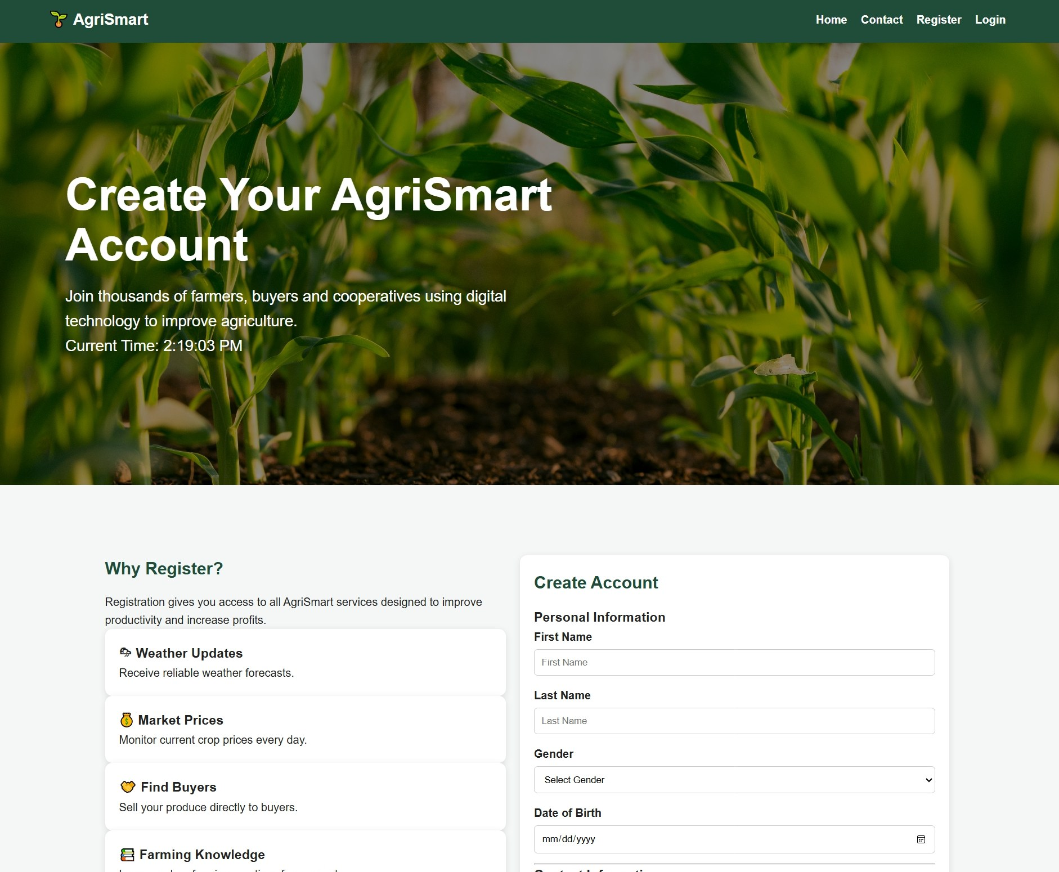
Figure 7: Registration Page
The figure above shows the Registration page, through which new users create an AgriSmart account. The form is organized into logical groups, Personal Information, Contact Information, User Information, Farm Information, and Security, capturing details such as name, gender, date of birth, email, phone number, province and district, user type, farm name, main crop, farm size, and farm location.
Client-side form validation, including required fields, password confirmation matching, and an explicit Terms and Conditions checkbox, ensures data quality before an account is created. Separating farmer-specific fields, such as main crop and farm size, from general contact details allows the same form to accommodate farmers, buyers, and cooperatives with minimal redundancy.

3.5.5 User (Farmer) Dashboard
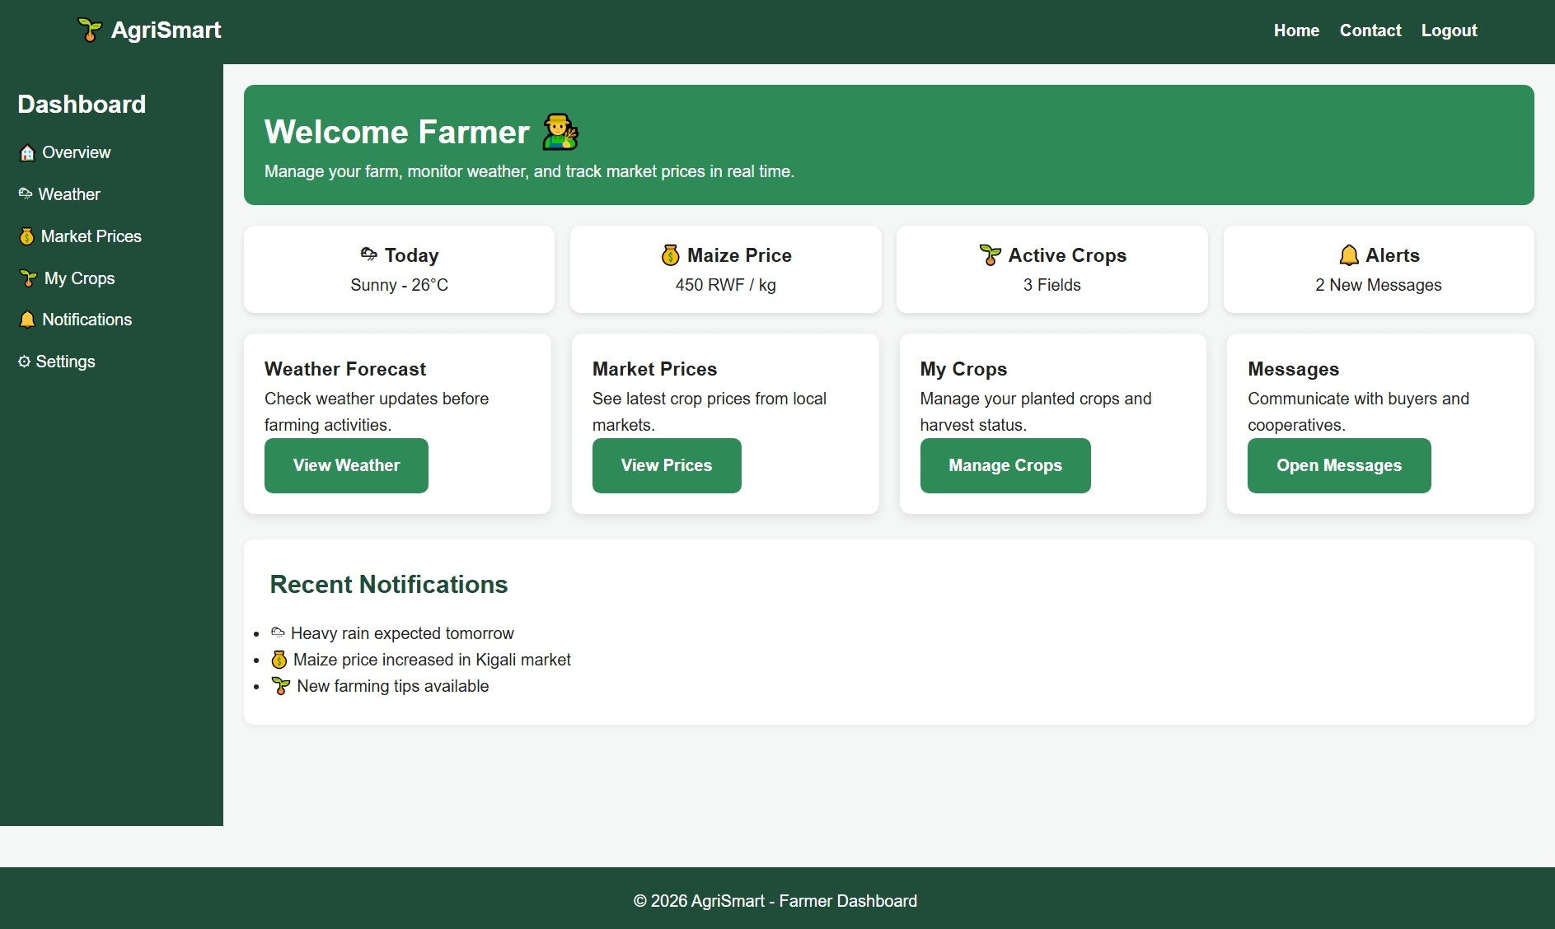
Figure 8: User Dashboard
The figure above shows the Farmer Dashboard, which welcomes the logged-in farmer and presents at-a-glance summary cards for today's weather, the current maize price, the number of active crop fields, and unread alerts. Below these, four quick-action panels give direct access to Weather Forecast, Market Prices, My Crops, and Messages.
A Recent Notifications panel keeps the farmer informed of time-sensitive events, such as an approaching heavy rain warning or a price increase in a nearby market. Together, these elements fulfil the dashboard's role of surfacing the most farming-relevant information immediately upon login, without requiring the farmer to navigate through multiple pages.

3.5.6 Administrator Dashboard
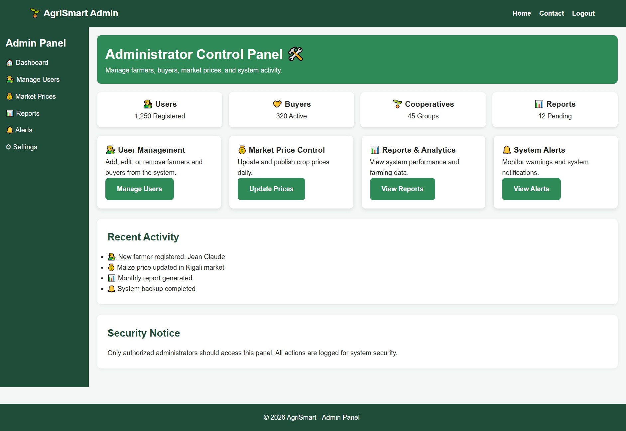
Figure 9: Administrator Dashboard
The figure above shows the Administrator Dashboard, which gives platform administrators an overview of total registered users, active buyers, cooperative groups, and pending reports, alongside management panels for User Management, Market Price Control, Reports and Analytics, and System Alerts.
A Recent Activity feed logs key platform events, such as new farmer registrations, price updates, and completed system backups, while a Security Notice reminds administrators that panel access is restricted and all actions are logged. This centralizes the administrative functions needed to keep AgriSmart's user base and market data accurate and up to date.

CHAPTER FOUR: TESTING
Manual black-box testing was used to verify AgriSmart's functionality, form validation, navigation, and responsiveness, on Chrome, Firefox, and Edge, including simulated mobile viewports.

4.1 Test Cases and Results
# | Test Case | Input | Expected Output | Status
1 | Farmer registration (valid data) | Complete valid form | Account created, redirect to login | Pass
2 | Registration (empty fields) | Blank required fields | Validation errors shown | Pass
3 | Login (correct credentials) | Valid email & password | Redirect to dashboard | Pass
4 | Login (incorrect password) | Wrong password | Error message displayed | Pass
5 | Contact form submission | Valid name, email, message | Confirmation message shown | Pass
6 | Contact form (invalid email) | Malformed email | Validation error shown | Pass
7 | Navigation links | Click each menu item | Correct page loads | Pass
8 | Responsive layout (mobile) | 375px viewport | Layout adapts, no overflow | Pass
9 | Farmer dashboard | Log in as farmer | Profile & requests displayed | Pass
10 | Admin dashboard | Log in as administrator | Statistics displayed correctly | Pass
Table 4.1: System Test Cases and Results

4.2 Summary
All ten executed test cases produced the expected results, confirming that AgriSmart's core functional and non-functional requirements are met at the current prototype stage.

CHAPTER FIVE: CONCLUSION AND RECOMMENDATIONS

5.1 Conclusion
AgriSmart successfully demonstrates a responsive, web-based Smart Agriculture Management System built with HTML5, CSS3, and JavaScript, addressing farmers' need for centralized weather, market, and buyer-connection information. All stated objectives were substantially achieved, and testing confirmed the system's core functionality and responsiveness.

5.2 Strengths and Limitations
- Strength: clean, responsive, role-based interface with strong client-side validation.
- Strength: well-organized, maintainable codebase.
- Limitation: no live back end, database, or real-time data feeds yet.
- Limitation: authentication is client-side only; not yet field-tested with real farmers.

5.3 Recommendations

What do you recommend?
Overall, it is recommended that AgriSmart proceed to a pilot phase with a small group of real farmers and buyers, supported by a back-end database and live weather/market data feeds, before wider rollout. The recommendations below are organized by audience.

To the lecturer, about technicalities
It is recommended that the lecturer provide additional guidance on back-end integration options (e.g., Node.js/PHP with a relational database) and on securing user authentication, since these were the main technical areas the current front-end-only prototype could not fully cover within the scope of the Web Design module.

To the school, about time constraints
It is recommended that the school allocate a longer project timeline, or split large web design projects across two terms, so that students have adequate time to complete both a polished front end and basic back-end integration, rather than a front-end prototype alone.

To the partners (owners of the business/sector targeted), about the app developed
It is recommended that agricultural stakeholders such as cooperatives, agro-dealers, and relevant government bodies (e.g., RAB, MINAGRI) review AgriSmart as a candidate pilot tool, provide feedback on real farmer and buyer workflows, and consider a data-sharing partnership for live weather and market price feeds.

To the user, about training
It is recommended that a short onboarding and training session, or an in-app help guide, be provided to farmers, buyers, and administrators before rollout, so that users with limited digital literacy can confidently register, navigate dashboards, and use the platform's features.

To the beneficiaries (farmers, buyers, and cooperative members), about the new technological tool
It is recommended that beneficiaries actively adopt and provide continuous feedback on AgriSmart, since the platform's value depends on real usage data, farmer participation, and buyer engagement to refine features such as market prices, farming tips, and buyer-farmer matching over time.

REFERENCES
Mozilla Developer Network. (2025). HTML, CSS, and JavaScript documentation. https://developer.mozilla.org
W3Schools. (2025). HTML5, CSS3, and JavaScript tutorials. https://www.w3schools.com
Rwanda Agriculture and Animal Resources Development Board. (2025). https://rab.gov.rw
Ministry of Agriculture and Animal Resources. (2025). Strategic Plan for Agriculture Transformation. https://minagri.gov.rw
World Wide Web Consortium. (2025). HTML5 and CSS Specifications. https://www.w3.org

APPENDICES

Appendix A: Selected Source Code
Selected excerpts of the HTML, CSS, and JavaScript source code implementing the registration form validation, responsive navigation menu, and dashboard rendering logic are provided below for reference.

Appendix B: GitHub Repository Access
Link to the account and password of the GitHub repository of the deployed project:
Repository URL: https://github.com/kevinish270/Smart-Agriculture-Web-App
Live Deployed Link: https://kevinish270.github.io/Smart-Agriculture-Web-App/

